--R1 Total sales

select sum(total_price) as TP from pizza_sales

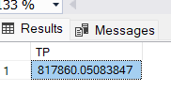

--R2 Avg Order Value

select sum(total_price) / count(distinct order_id) as AOV from pizza_sales

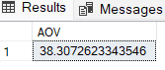

--R3 Total Piza Sold

select sum (quantity) as TQP from pizza_sales

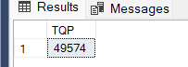

--R4 Total Order Placed

select count(distinct order_id) as Totalorderplace from pizza_sales

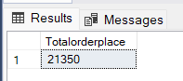

--R5 Average Pizza/Order

select (cast(sum(quantity) as decimal(10,2)) / cast(count(distinct order_id) as decimal(10,2)))

as Avgpizzaperorder

from pizza_sales

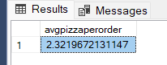

--R6 Day wise sale

select DATENAME(DW,order_date) as Order_day,

COUNT(distinct order_id) as Total_Orders

from pizza_sales

group by DATENAME(DW,order_date)

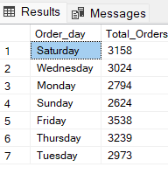

--R7 MOnth_wise sale

select DATENAME(MONTH,order_date) as Month_Name,

COUNT(distinct order_id) as Total_Orders

from pizza_sales

group by DATENAME(MONTH,order_date)

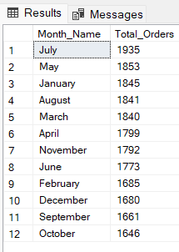

#WITH MONTH AS A FILTER

--R8 Percent of sales by pizza category

select pizza_category,(sum(total_price)*100 / (select sum(total_price) from pizza_sales)) as Revenue

from pizza_sales as Revenue

group by pizza_category

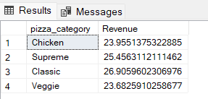

select pizza_category,sum(total_price) as TP ,

(sum(total_price)*100 / (select sum(total_price) from pizza_sales where month(order_date)=1)) as Revenue

from pizza_sales

where month(order_date)=1

group by pizza_category

--R9 Percent of sales by Size

select pizza_size,sum(total_price) as TSALES ,CAST

(sum(total_price)*100 /

(select sum(total_price) from pizza_sales) as decimal(10,2)) as PCT

from pizza_sales

group by pizza_size

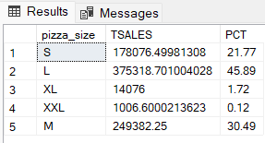

#FOR QUARTER 1 using datepart

select pizza_size,sum(total_price) as TSALES ,CAST

(sum(total_price)*100 /

(select sum(total_price) from pizza_sales) as decimal(10,2)) as PCT

from pizza_sales

where datepart(QUARTER,order_date)=1

group by pizza_size

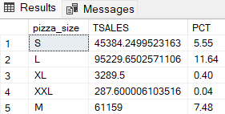

--R10 top5 Best seller by Revenue ,Total Quantity and Total Order

select TOP 5 pizza_name, sum(total_price) as TS

from pizza_sales

group by pizza_name

order by TS DESC

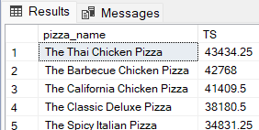

#BOTTOM 5

select TOP 5 pizza_name, sum(total_price) as TS

from pizza_sales

group by pizza_name

order by TS

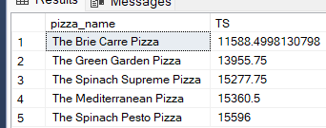

#FoR COUNTS

select TOP 5 pizza_name, count(distinct order_id) as TC

from pizza_sales

group by pizza_name

order by TC

